

|  |
| --- |
| Apparel & Footwear |
| **Picking and Packing** |
| Argentis Consulting |



**www.argentisconsulting.com**

Delivery Wizard

The Delivery Wizard allows logistics to create Delivery Documents in a process.

Go to: *Apparel and Footwear 🡪 Inventory 🡪 Pick and Pack 🡪 Pick and Pack Manager*

Select the posting dates of the documents to be picked.

Click on the type of Documents to be picked and the Warehouses. Also, you can filt and if you complete the fields listed below to perform a filtered search if desired.

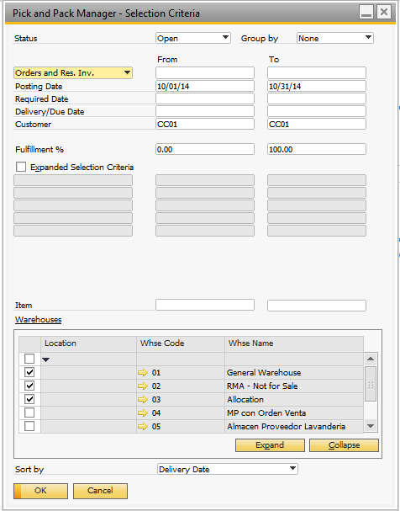

Select the Items and Sales Order to be pick.

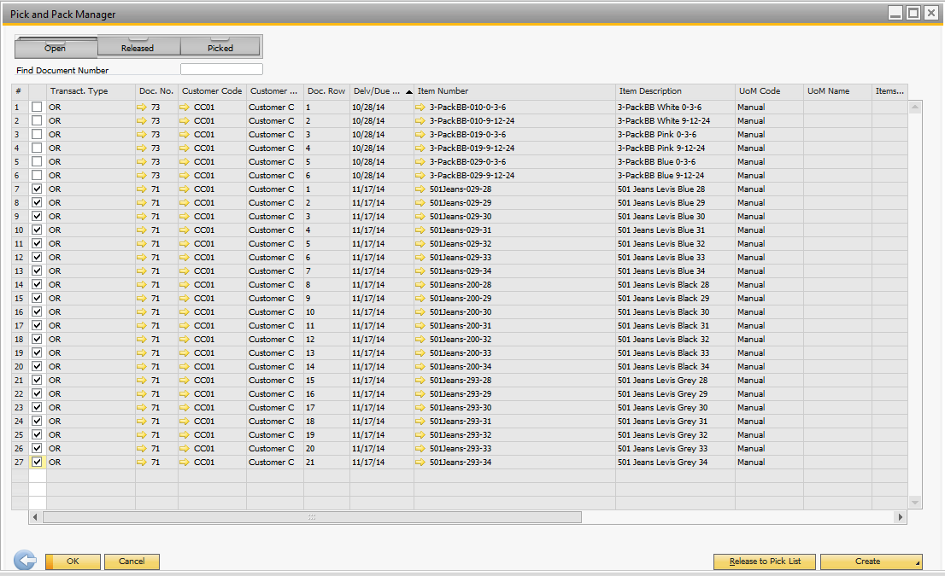

And Select the option Release to Pick List. The Pick List Generation enables you to generate picks list for specific warehouse, warehouses sublevels, and bin locations.

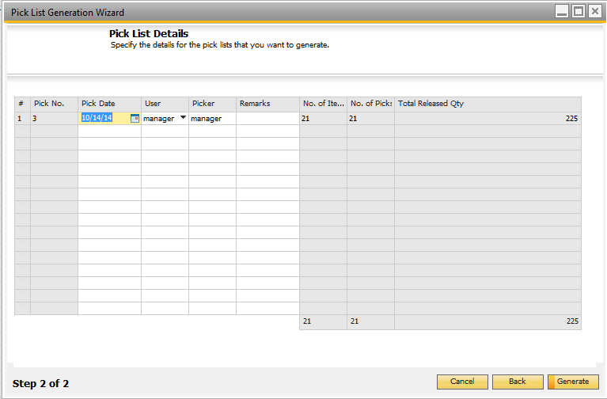

Select the option “Generate” to Release the Picking

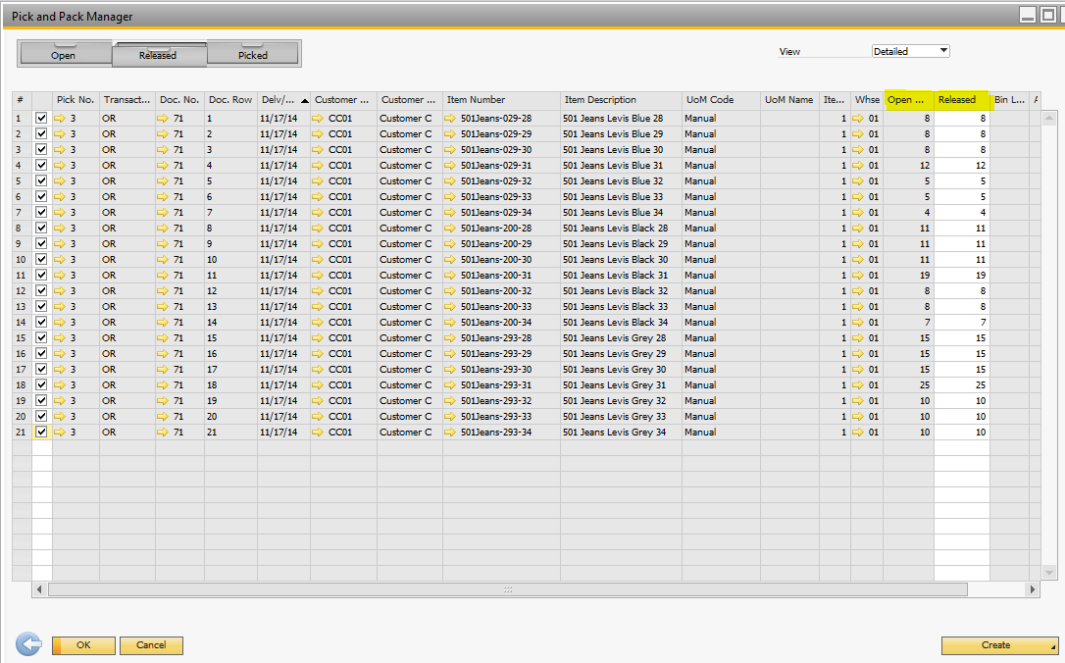

It´s possible to create: Manual Delivery, Automatic delivery, and Manual Invoice.

If you select Automatic Delivery, the Delivery Document is created.

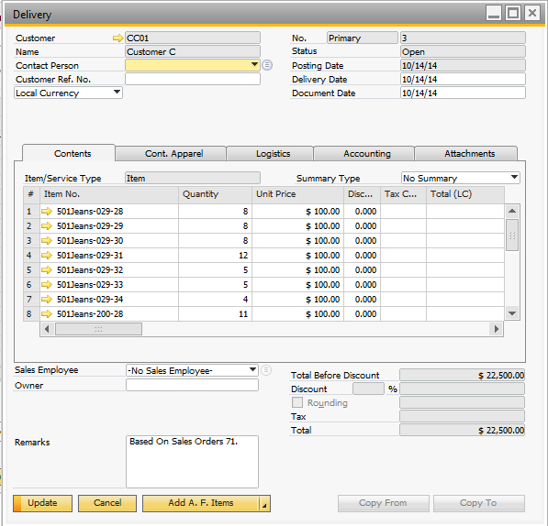

To Visualize the Pick List created, in the Menu go to: Apparel and Footwear 🡪 Inventory 🡪 Pick and Pack 🡪 Pick List

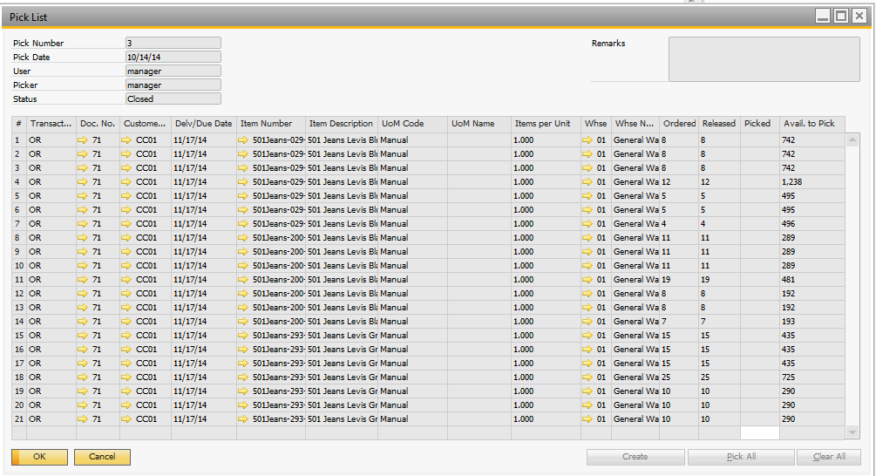

**Print Pick List**

In the Menu: Apparel and Footwear 🡪 Inventory 🡪 Pick and Pack 🡪 Print List Picking

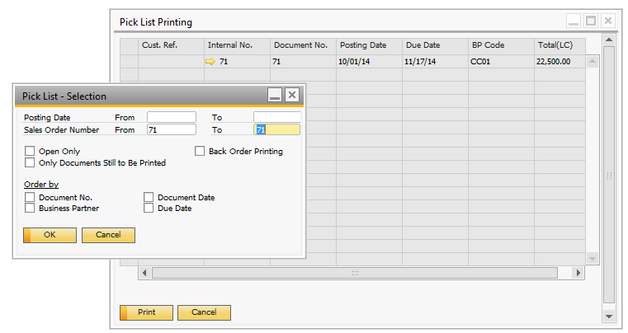

**Packaging Wizard**

The packaging wizard allows users to enter deliveries based on customer reference numbers (PO#), and allocate items in predefined packages types. Then export the file to print the Container labels.

Note: You can proceed to the packaging wizard after you create a delivery document from the pick and pack manager or delivery document.

Go to Pick & Pack Manager 🡪 Packaging Wizard. Select the Delivery Notes you want to add to the packaging wizard.

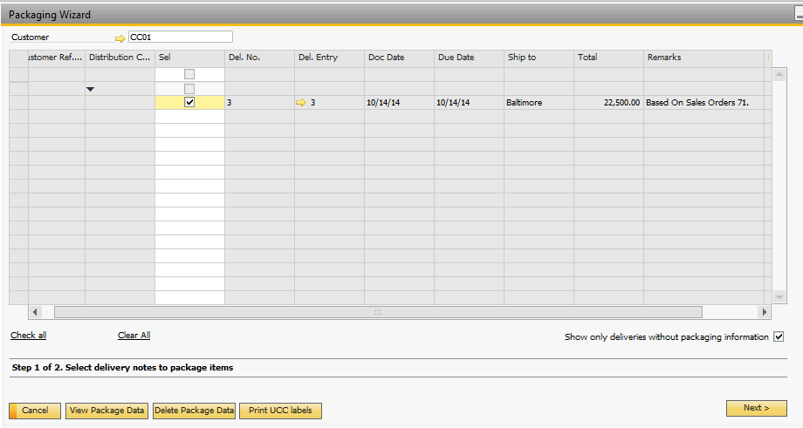

Select Delivery Lines to package.

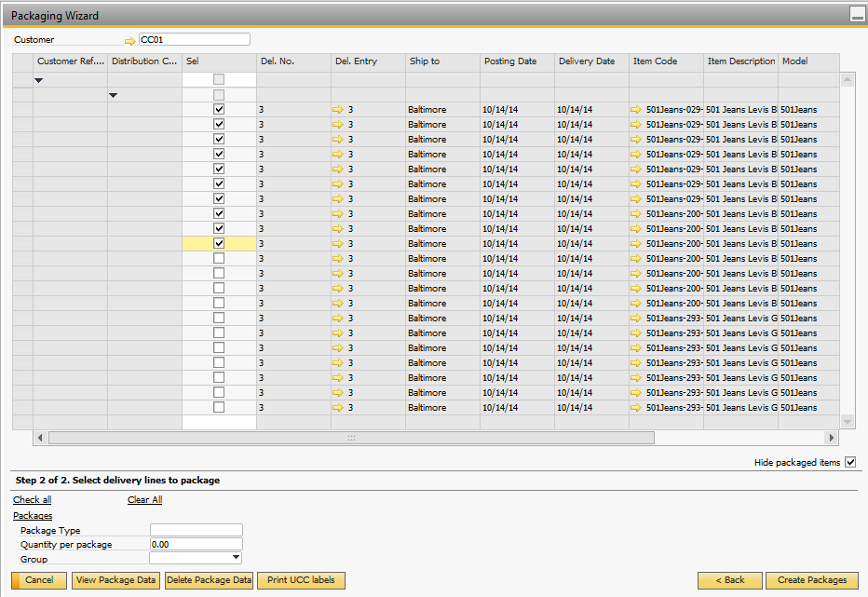

Select Package types. Click on the Setup Packaging button. Select an existing SAP package Type (Administration 🡪 Setup 🡪 Inventory 🡪 Package Types). Click on the “Create Packaging Data” button

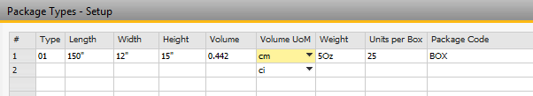

You are also able to Group the items according the Model Color or the Model Scale.

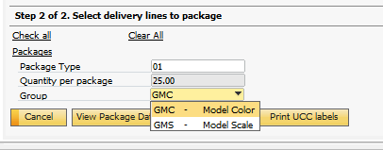

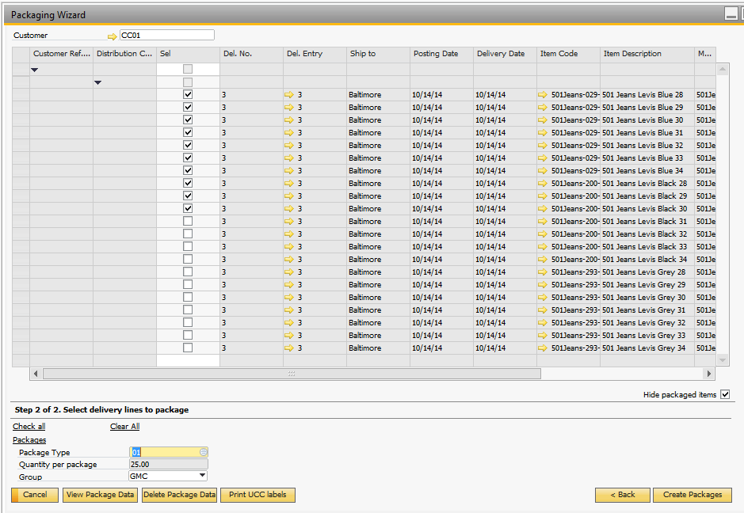

The wizard allocates the items in each box

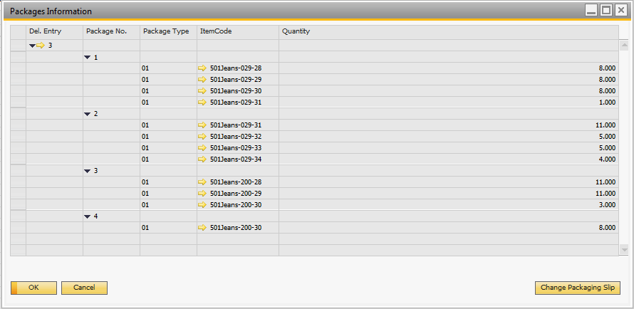

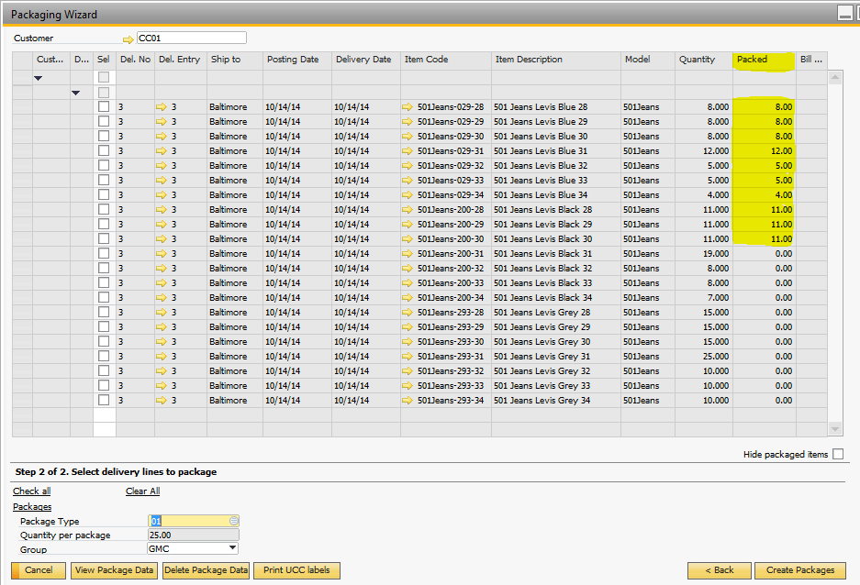

With the option View Package Data you can visualize the packages information.

Or in the Delivery Note, in the Menu option Packing List, you are able to visualize the packing. Slip

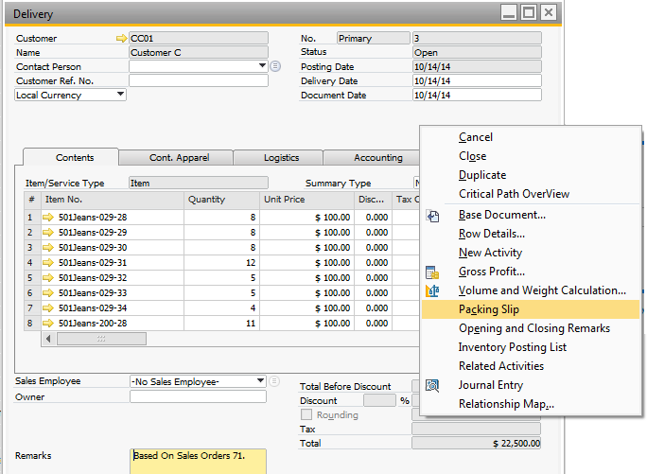

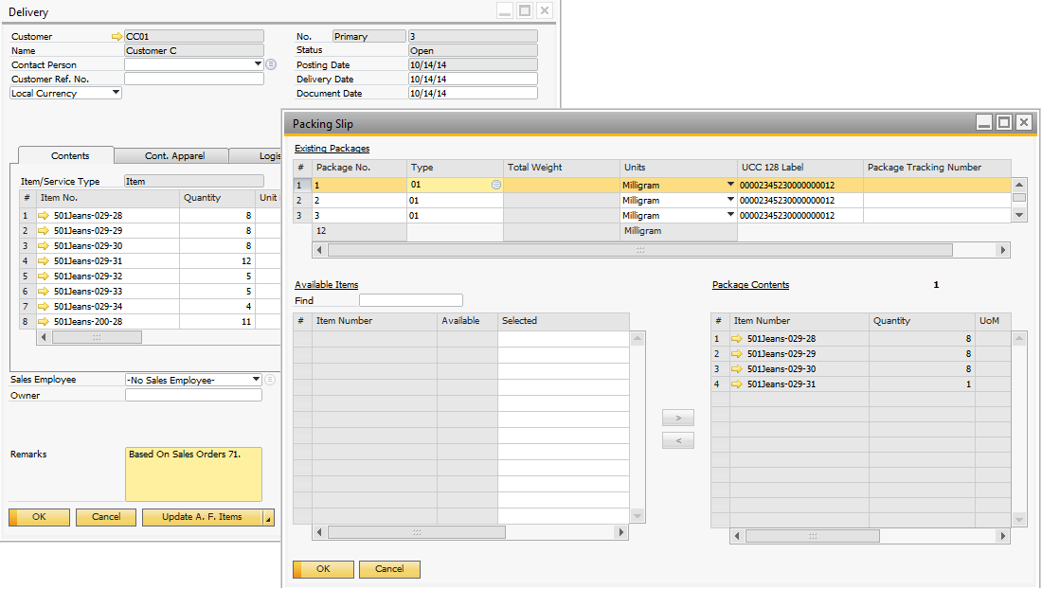



**www.argentisconsulting.com**

|  |  |
| --- | --- |
| **USA**  9744 NW 45th Lane  Doral, FL 33178  info@argentisconsulting.com | **ARGENTINA**  Ávila y Zarate 2048  Cerro de la Rosas, Córdoba,  CP 5009  Córdoba - Argentina  info@argentisconsulting.com |
| **CARIBEAN**  City View Plaza – Suite 301  48 Road 165  Guaynabo, PR. 00968  Puerto Rico  caribe@argentisconsulting.com | **SPAIN**  C/ Juan Bravo N° 3 A 28006  Phone: (+34) 91 123 7263  Madrid - Spain  info@argentisconsulting.com |

**INFORMACIÓN DE CONTACTO**

**Argentis Consulting** is dedicated to the development, distribution   
and support of recognized certified solutions for SAP Business One.   
As an SAP Software Service Provider Partner with Gold Status.